Matthew Oliver

[Company name]  [Company address]

[Document title]

Contents

Introduction 2

Making a Character 3

Choosing a Species 3

Choose a Background 3

Determining your Attributes 3

Select your Starting Feats 3

Starting Equipment 3

Leveling Up 3

Species 4

Human 4

Wapiti (Elk Folk) 4

Ouaouron (Frog Men) 5

Mawa (Orangutan Men) 6

Iwana (Iguana Folk) 6

Feats 8

Backgrounds 9

Equipment 10

Using Attributes and Skills 11

Adventuring 12

Combat 13

Spellcasting 14

# Introduction

# Making a Character

## Choosing a Species

The creation of every adventurer starts by choosing a species. The world of [WORLD NAME] contains a wide variety of intelligent species. Will you choose to be one of the Amphibian Folk? Or maybe one of the Ape Men? Various species can be found almost anywhere in the world of [WORLD NAME] and any background is available to any species, so feel free to choose whichever one looks like the most fun to you.

Your species affects several aspects of your character, including a bonus to one of your attributes, your starting language(s), your size, your base movement speed(s), and can include some other traits.

You can choose a species that suits the character you want to make or just go wild. Just because Ouaouran get a bonus to Dexterity doesn’t mean that you have to play a Dexterity based character. Be a Frog Wizard! Or maybe an Elk Assassin? The possibilities are endless!

## Choose a Background

Who were you before you became an adventurer? Were you a blacksmith? Maybe a thief? Your background can give you one or several bonuses to start with, giving you a head start on the road to building the adventurer you want.

Most backgrounds will let you start as a Novice in one of the Profession Skills and may give bonuses to other Skills as well. Your background will also give you a couple pieces of starting equipment, easing your initial spending.

## Determining your Attributes

All beings in [WORLD NAME] have six basic attributes. These are Strength, Dexterity, Constitution, Intelligence, Acuity, and Will. These attributes represent a being’s various physical and mental abilities.

At Level 1 all adventurers start with the same basic spread of stats. Choose two of your attributes to be Tier 3, three to be Tier 2, and one to be Tier 1.

It is recommended that you choose your attribute spread based on the kind of character you want to be. Are you going to be a sword-wielding knight? Strength and Constitution are your friends. Want to be a spell-slinging mage? Intelligence and Will are what you need. Choose an attribute spread that best fits the play style you’re going for.

## Select your Starting Feats

At level one every adventurer starts with the following: two Narrative Feats, one Combat Feat, one Profession Feat, and either a Martial Feat or a Magic Feat.

Your feats are what determines your adventurer’s playstyle so make sure to choose them based on who you want to play. Also make sure to choose them based on what feats you’ll have access to as you go down those trees, you might find that while one feat fits your playstyle better now, there might be feats in another section of the tree that will fit your character better.

## Starting Equipment

## Leveling Up

# Species

## Human

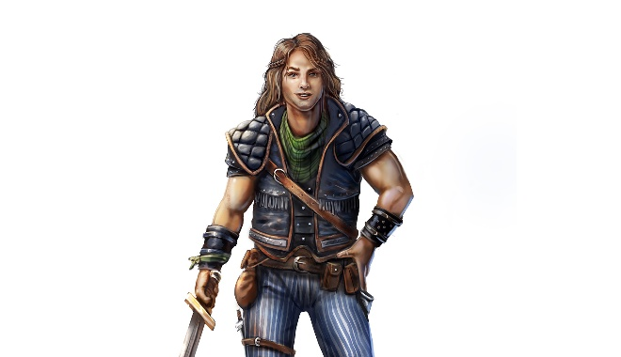

Bonuses

Humans are an extremely varied race, coming in all shapes and sizes. Choose one Attribute to increase by a tier.

Languages

[COMMON LANGUAGE], Outworld

Aging

Humans reach maturity at around the age of 20 and live until around 80.

Size

Humans are medium creatures.

Movement

Humans have a base walking speed of 45ft.

Appearance

Culture

History

Other Traits

## Wapiti (Elk Folk)

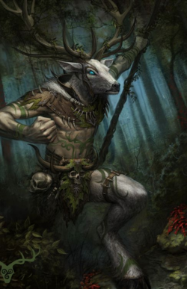

Bonuses

Wapiti are naturally strong, increase your strength attribute by one tier.

Languages

[COMMON LANGUAGE], [SYLVAN LANGUAGE]

Aging

Wapiti reach maturity at the age of five and live about forty years.

Size

Wapiti are medium creatures.

Movement

Wapiti have a base walking speed of 60ft.

Appearance

Culture

History

Other Traits

All Wapiti possess horns, which start growing once they reach maturity. These horns count as a natural weapon and can be found in [NATURAL WEAPONS APPENDIX]

## Ouaouron (Frog Men)

Wad-ah-rohn

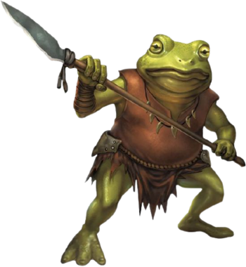

Bonuses

Ouaouron are naturally mobile, increase your dexterity attribute by one tier.

Languages

[COMMON LANGUAGE], [AMPHIB LANGUAGE]

Aging

Ouaouron are born as tadpoles, which gradually grow into adults, reaching maturity at the age of two. Ouaouron live until about twenty.

Size

Ouaouron are medium creatures.

Movement

Ouaouron have base walking and swimming speeds of 30ft.

Appearance

Culture

History

Other Traits

Ouaouron are natural jumpers and universally have the **Leap** ability, found in the [ABILITIES APPENDIX]

Ouaouron have a long, sticky tongue, which counts as a natural weapon, found in the [NATURAL WEAPONS APPENDIX]

## Mawa (Orangutan Men)

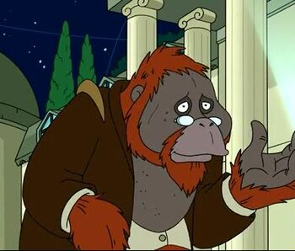

Bonuses

Mawa are naturally intelligent, increase your intelligence attribute by one tier.

Languages

[COMMON LANGUAGE], [APE LANGUAGE]

Aging

Mawa reach maturity at the age of 15 and live until around 60

Size

Mawa are medium creatures.

Movement

Mawa have base walking and climbing speeds of 30ft.

Appearance

Culture

History

Other Traits

## Iwana (Iguana Folk)

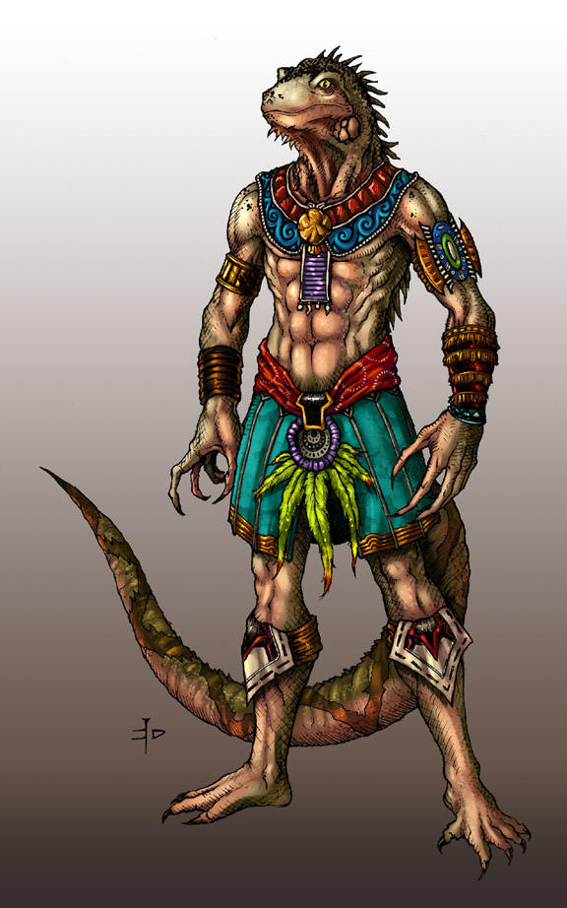

Bonuses

Iwana are naturally dexterous, increase your dexterity attribute by one tier

Languages

[COMMON LANGUAGE], [SOUTH AMERICA REPTILE LANGUAGE]

Aging

Iwana reach maturity at the age of 5 and live to around 30

Size

Mawa are medium creatures.

Movement

Mawa have base walking and swimming speeds of 30ft.

Appearance

Culture

History

Other Traits

# Feats

# Backgrounds

# Equipment

# Using Attributes and Skills

# Adventuring

# Combat

# Spellcasting